1. UPDATE passengers SET date_of_birth = CURRENT_DATE - INTERVAL '10 years'
WHERE date_of_birth > (CURRENT_DATE - INTERVAL '10 years');

ALTER TABLE passengers ADD CONSTRAINT chk_passenger_age
CHECK (date_of_birth <= CURRENT_DATE - INTERVAL '10 years');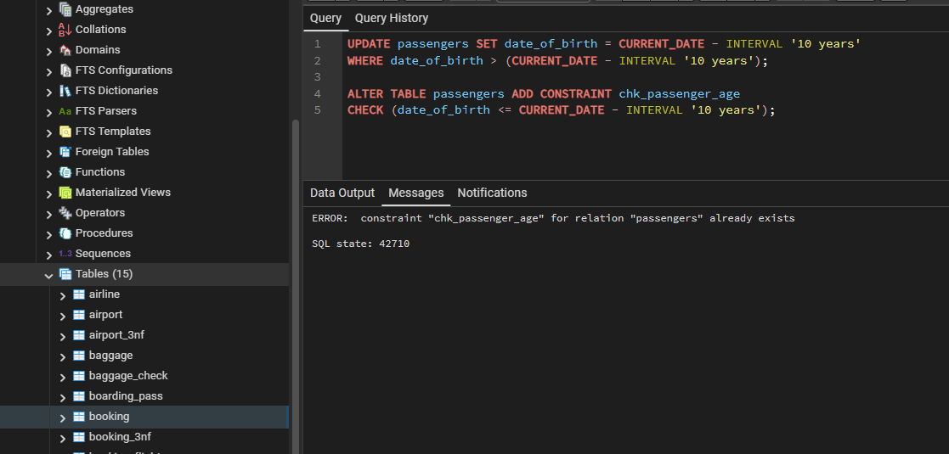

2. UPDATE booking
SET ticket_price = 50000
WHERE ticket_price > 50000;

UPDATE booking
SET ticket_price = 0
WHERE ticket_price < 0;

ALTER TABLE booking
ADD CONSTRAINT chk_booking_price
CHECK (ticket_price >= 0 AND ticket_price <= 50000);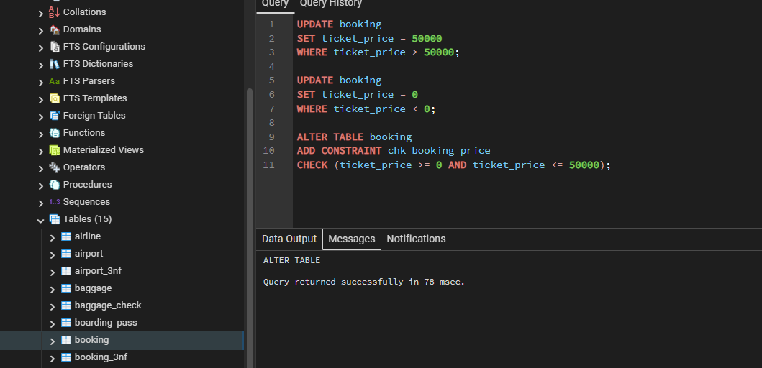

3. UPDATE baggage
SET weight_in_kg = 23
WHERE weight_in_kg > 23;

UPDATE baggage
SET weight_in_kg = 1
WHERE weight_in_kg < 1;

ALTER TABLE baggage
ADD CONSTRAINT chk_baggage_weight
CHECK (weight_in_kg >= 1 AND weight_in_kg <= 23);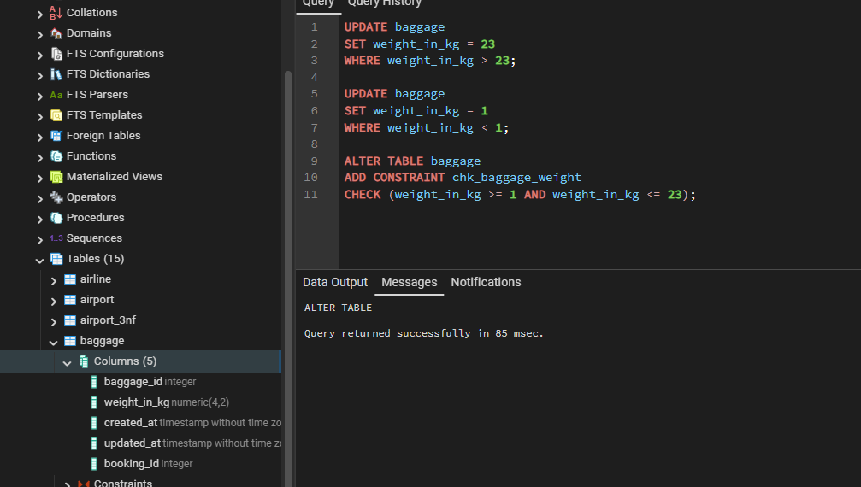

4. UPDATE airport
SET airport_name = RPAD(airport_name, 10, '_')
WHERE LENGTH(airport_name) < 10;

ALTER TABLE airport
ADD CONSTRAINT chk_airport_name_length
CHECK (LENGTH(airport_name) >= 10);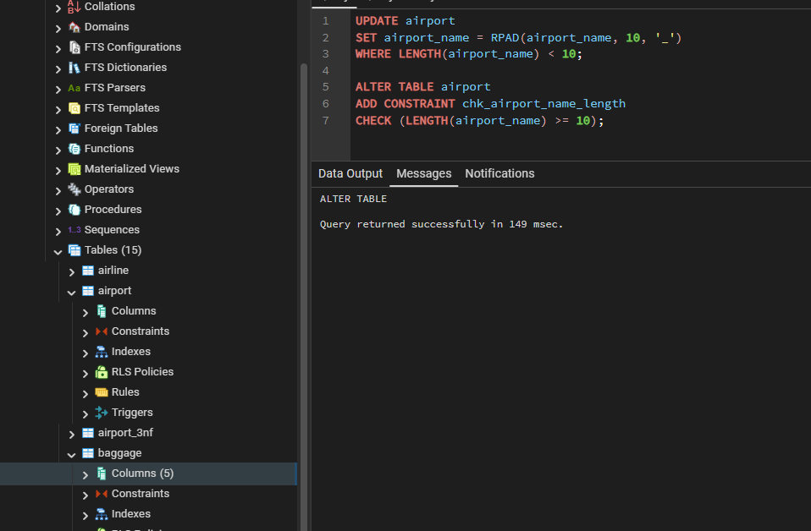

5. UPDATE passenger
SET passport_number = passport_number || '_' || passenger_id
WHERE passport_number IN (
SELECT passport_number
FROM passenger
GROUP BY passport_number
HAVING COUNT(*) > 1
);

ALTER TABLE passenger
ADD CONSTRAINT uq_passenger_passport UNIQUE (passport_number);

UPDATE airline
SET airline_name = airline_name || '_' || airline_id
WHERE airline_name IN (
SELECT airline_name
FROM airline
GROUP BY airline_name
HAVING COUNT(*) > 1
);

ALTER TABLE airline
ADD CONSTRAINT uq_airline_name UNIQUE (airline_name);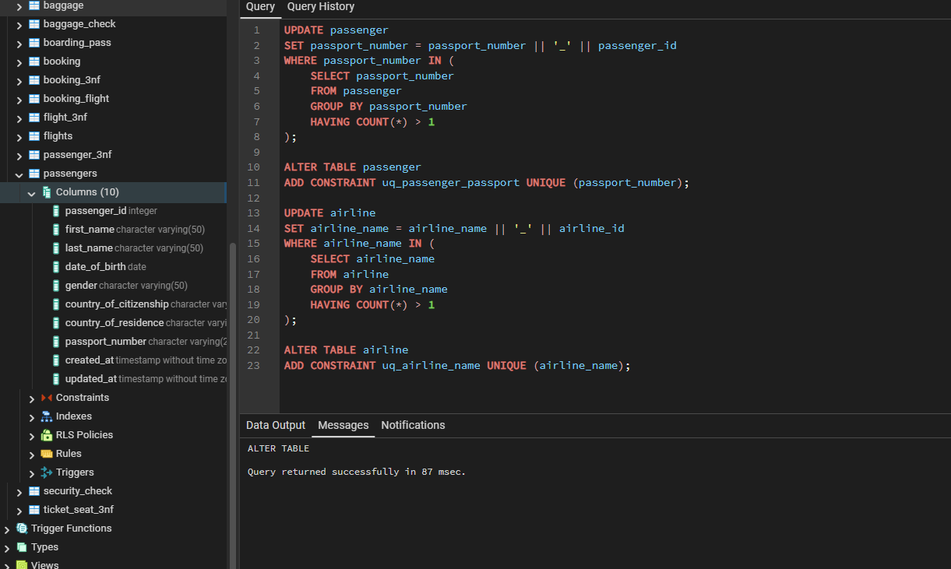

6. UPDATE passengers
SET date_of_birth = CURRENT_DATE - INTERVAL '18 years'
WHERE gender = 'Male' AND date_of_birth > (CURRENT_DATE - INTERVAL '18 years');

UPDATE passengers
SET date_of_birth = CURRENT_DATE - INTERVAL '19 years'
WHERE gender = 'Female' AND date_of_birth > (CURRENT_DATE - INTERVAL '19 years');

ALTER TABLE passengers
ADD CONSTRAINT chk_gender_age CHECK (
(gender = 'Male' AND date_of_birth <= CURRENT_DATE - INTERVAL '18 years') OR
(gender = 'Female' AND date_of_birth <= CURRENT_DATE - INTERVAL '19 years')
);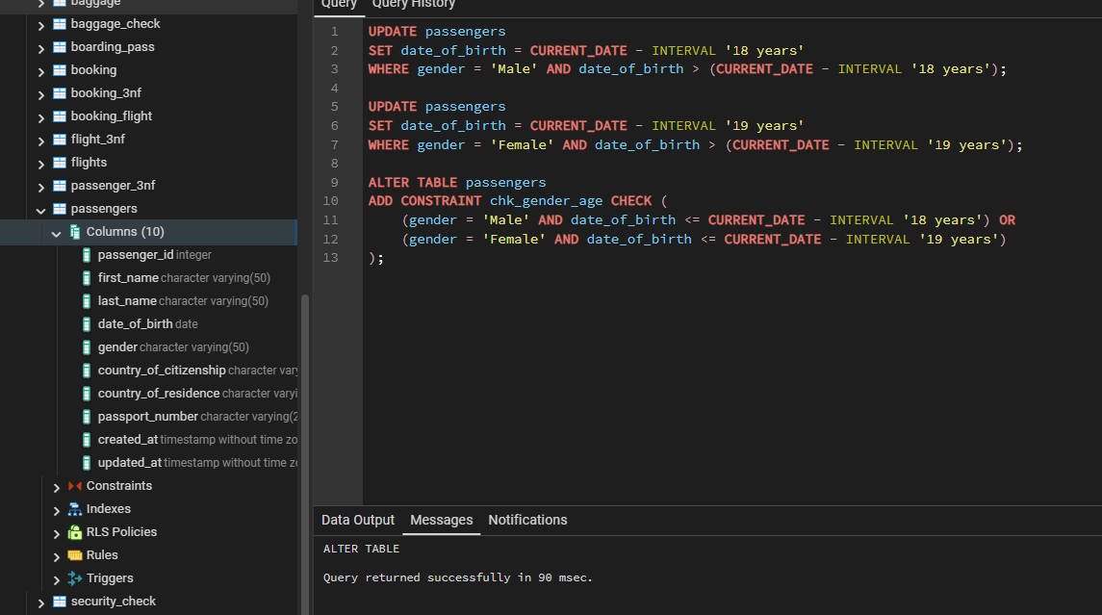

7. ALTER TABLE passengers
ADD CONSTRAINT chk_citizenship_age CHECK (
(country_of_citizenship = 'Kazakhstan' AND date_of_birth <= CURRENT_DATE - INTERVAL '18 years') OR
(country_of_citizenship = 'France' AND date_of_birth <= CURRENT_DATE - INTERVAL '17 years') OR
(country_of_citizenship NOT IN ('Kazakhstan', 'France') AND date_of_birth <= CURRENT_DATE - INTERVAL '19 years')
);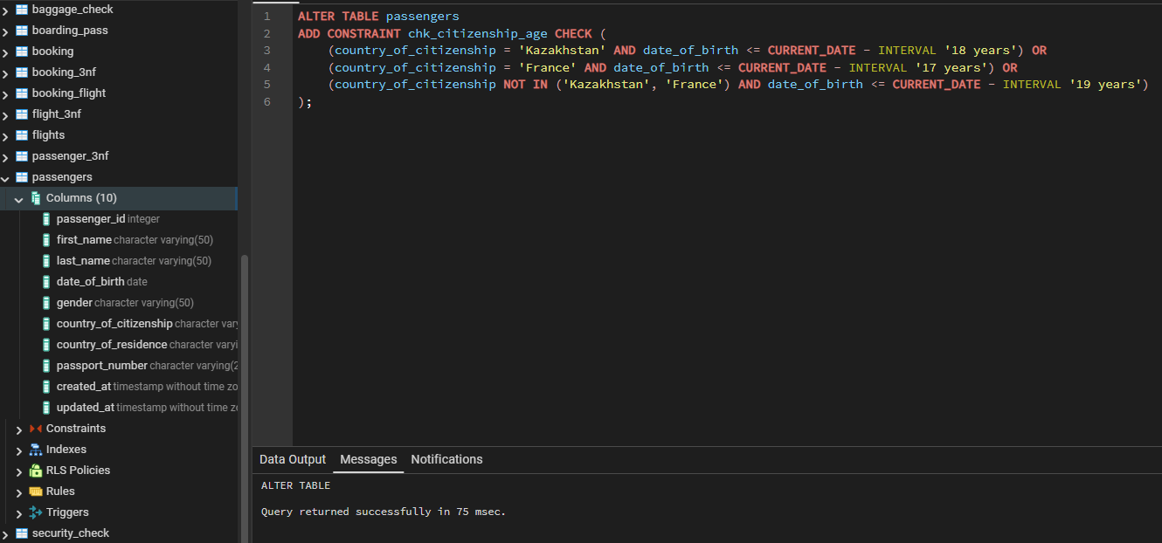

8. ALTER TABLE booking
ADD COLUMN ticket_discount NUMERIC(5, 2);

UPDATE booking
SET ticket_discount = CASE
WHEN created_at >= '2024-01-01' THEN 5.00
ELSE 10.00
END;

ALTER TABLE booking
ADD CONSTRAINT chk_ticket_discount CHECK (
(created_at >= '2024-01-01' AND ticket_discount = 5.00) OR
(created_at < '2024-01-01' AND ticket_discount = 10.00)
);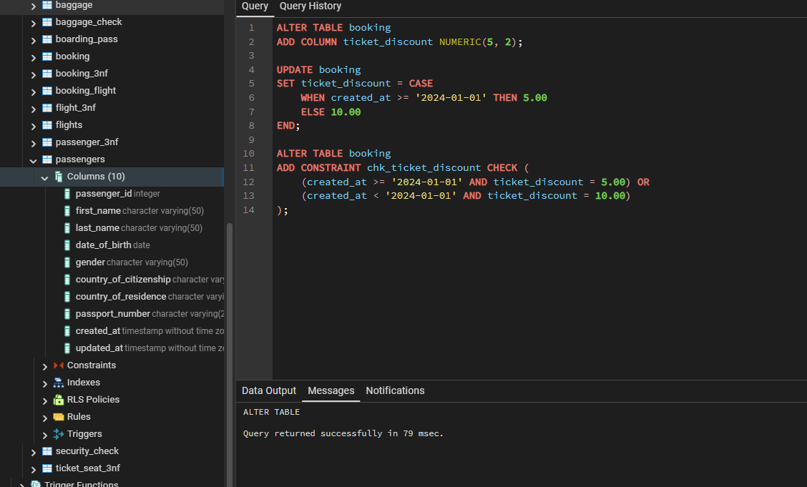

9. ALTER TABLE booking
ALTER COLUMN status SET DEFAULT 'Confirmed';

INSERT INTO booking (booking_id, flight_id, passenger_id, booking_platform, ticket_price, ticket_discount, created_at, updated_at)
VALUES (
COALESCE((SELECT MAX(booking_id) FROM booking), 0) + 1,
(SELECT flight_id FROM flights LIMIT 1),
(SELECT passenger_id FROM passengers LIMIT 1),
'Web',
25000.00,
5.00,
NOW(),
NOW()
);

SELECT * FROM booking;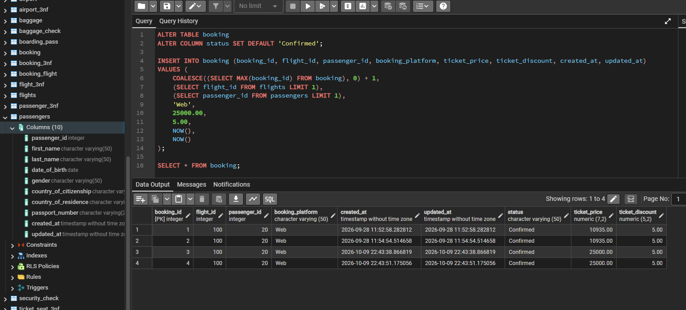

10. ALTER TABLE booking
ALTER COLUMN created_at SET DEFAULT NOW();

ALTER TABLE baggage_check
ALTER COLUMN created_at SET DEFAULT NOW();

SELECT * FROM booking,baggage_check;